# Software and Permissions for New Applications Development Staff

## Software

The following software should be installed for new staff:

* Technical Support will install basic applications (Outlook, Teams, Corporate Apps, CRM permissions, etc.)
* Only if there’s the possibility of supporting legacy applications:
  + Visual Studio 2008
  + Visual Studio 2013
* Visual Studio 2017 - free Community edition from <https://visualstudio.microsoft.com/downloads/>
* SQL Server Management Studio 2014
* Microsoft Visio 2010
* If they are a developer, install Node.js

Permissions

The following permissions should be assigned to the new staff:

* TFS - overall access given by admin (David, Mike) as well as per project. For overall access, admin needs to open TFS home page, click on Settings, then if they are an admin they will see the “Access levels” tab. Check if user if part of Information Management, if not then add them separately.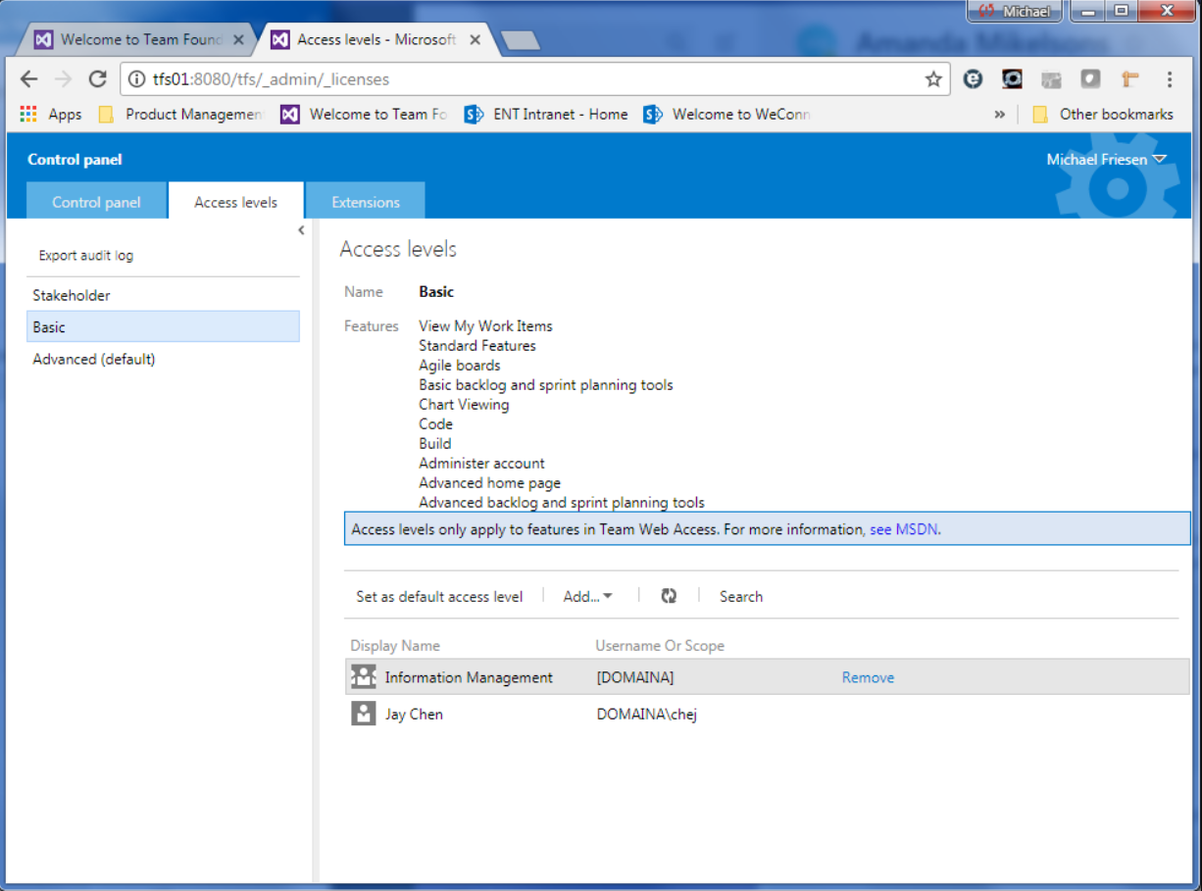
* TFS – E1 license needs to be activated by Tech Support (Robin Milburn knows how).
* Database access – send request to DBA
* Teams. An admin must add them. In Teams under the “Teams” tab, click on AppDev and then “...” and “Manage team”. Add to members.
* If staff member will be supporting or needing Corporate Apps, send email to Technical Support CEC requesting permissions to Corporate Apps.

## Links

* TFS <http://tfs01:8080/tfs/_home>
* Sharepoint [https://healthstandards.sharepoint.com/SitePages/Home.aspx](https://healthstandards.sharepoint.com/SitePages/Home-old.aspx)
* Yammer <https://www.yammer.com/accreditation.ca/?show_login=true#/home>
* Old Sharepoint <http://webdoc01/sites/intranet/Teams/IMTeam/SitePages/Home.aspx>
* Timesheets <https://gpserver.internationalaccreditation.ca/GP/Account/LogOn>